**Littleton Garden Club Receives Plant America Grant**

**Submitted by Betsy Fraser, President Littleton Garden Club**

**Fraser_elizabeth@hotmail.com** **603-991-7749**

The Littleton Garden Club has received a Plant America Community Project Grant from the National Garden Clubs, Inc. located in St. Louis, Missouri. The club requested the funds to purchase mulch, plants and other supplies needed to tend gardens and window boxes in Littleton, New Hampshire for the 2024 summer season.

Have you seen club members working in the gardens and at the window boxes in Littleton? Each spring the Littleton Garden Club jumps to action in May to do spring cleanup and mulch the flower gardens located along Littleton’s Main Street, extending from the Triangle on West Main, to the gardens in front of Dunkin’ Donuts on Main Street, multiple gardens at Littleton Community Center, and a butterfly garden and the Rita McAvoy bird habitat at the Opera House. Window boxes are planted with red, white and blue flowers at the Post Office, the Opera House and on Veterans Memorial Bridge and a wreath is placed at the War Memorial in the New Hampshire Bank Plaza. Club members tend the gardens and window boxes through the summer months until everything is put to bed in the fall.

National Garden Clubs established the Plant America Community grant program in 2017 and has awarded over 250 grants. Grants may be used for physical landscaping or environmental projects, or horticultural opportunities for the community.

Littleton Garden Club President, Betsy Fraser, explains, “In 2023 our club purchased nearly $1,000 in supplies to prepare the Littleton gardens and window boxes for the summer season. This is a big expense for a small nonprofit organization. In the Plant America grant request, we listed the gardens and window boxes tended in Littleton, the benefit they provide for the community, and we requested funds of $960 to purchase garden supplies for the 2024 season. We were surprised and delighted when our club was selected from more than 140 applications to receive a grant.”

The Littleton Garden Club is pleased to contribute to the greening of Littleton. For many years the club, and in fact society, regarded community gardens and window boxes as something pretty to help beautify public places. Today we think more broadly than that. When we see a Monarch butterfly taking nectar at a flower in a garden at the Community Center, or birds nesting in the Rita McAvoy Bird Habitat which is a small strip of land behind a parking barrier at the Opera House parking lot, or bees at flowers in the Dunkin’ Donut gardens, we realize that the gardens and window boxes not only add beauty to the town, but they provide important green islands in the urban setting of Littleton. These green islands bring a sense of beauty for people and they enhance the community’s environmental well-being by supporting pollinators and birds that are critical to the web of life. Going forward, the club is excited to further evaluate the gardens they tend and introduce more native plants.

Littleton Garden Club welcomes new members any time and more information about the club is available at littletonnhgardenclub.org

Photos….just in case there’s space and interest…..

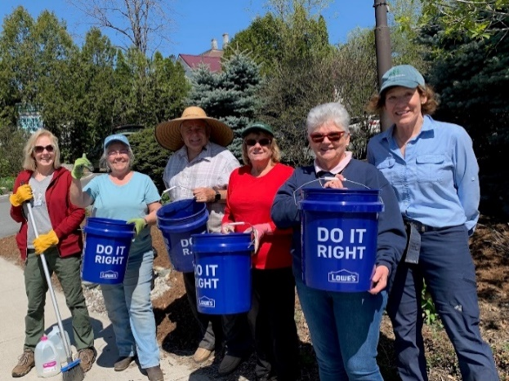

Caption: Members of the Littleton Garden Club prepare to mulch the gardens in front of Dunkin’ Donuts.

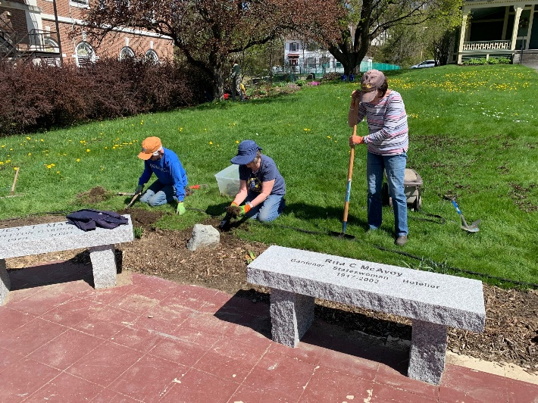 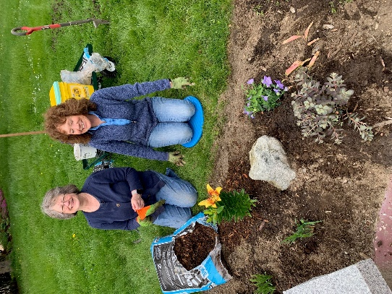

Caption: Members of Littleton Garden Club expand and plant the garden surrounding the platform at the Littleton Community Center.

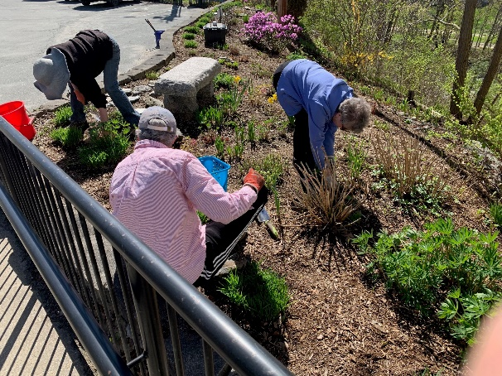

Caption: Members of Littleton Garden Club tend the butterfly garden at the entrance to the Opera House.

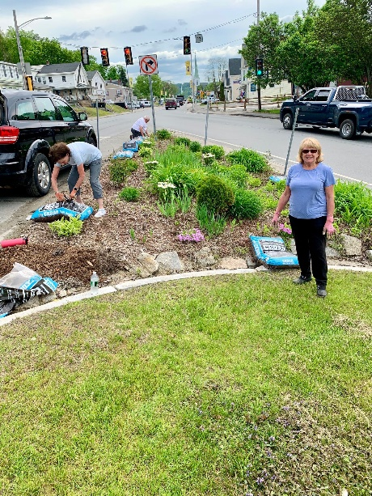

Caption: Club members mulch the Triangle garden at the busy intersection of West Main and Meadow Street.